

© 2014 Inner Power Mentors LLP, All rights reserved.
ALL RIGHTS RESERVED. This document contains material protected under Indian Copyright Act, 1957.
Any unauthorized reprint or use of this material is prohibited. No part of this document may be reproduced or transmitted in any form or by any means, electronic or mechanical, including photocopying, recording, or by any information storage and retrieval system without express written permission from the author.

© Inner Power LLP, Bangalore, All rights reserved.
ALL RIGHTS RESERVED. This document contains material protected under Indian Copyright Act, 1957.
Any unauthorized reprint or use of this material is prohibited. No part of this document may be reproduced or transmitted in any form or by any means, electronic or mechanical, including photocopying, recording, or by any information storage and retrieval system without express written permission from the author.

Leadership for Changing Times
Contents

1. About “Inner Power: Leadership for Changing Times”: 3
2. Take Away/Benefits: 4
3. Themes: 5
4. Speakers 5
5. Schedule 6
6. Venue 7
7. Who should attend? 7
8. Appendix 8
8.1. Leading Change 8
8.2. Principal Themes 11
8.2.1. Leadership & Coaching Culture for High Performance 11
8.2.2. Jumpstarting Performance by harnessing Passion, Belief & Adaptability 11
8.3. Secondary Themes 12
8.3.1. Emotional Intelligence for Peak Performance 12
8.3.2. Self Care & Personal Energy Management: 12
8.3.3. Influential Communication 12
8.3.4. Self-Inspiration: 13
8.3.5. Contribution/Fulfilment 13
8.4. Themes 13
8.4.1. Principal Themes 13
8.4.2. Secondary Themes 13
8.5. Who should attend? 14

About “Inner Power: Leadership for Changing Times”:

Inner Power: “Leadership for Changing Times”

IPTS is organizing its 2 days workshop event “Leadership for Changing Times” at Holiday Inn Goa, from 26th to 28th Sep. A workshop to address the need for a transformational leadership mind-set to capture opportunities and address the challenges faced in the predicted upswing of the Indian economy.
“Inner Power: Leadership for Changing Times” is an open event for working professionals, passionate entrepreneurs and all those who look forward to lead and inspire (themselves and others) to make peak performance a regular habit. It includes a series of workshop segments and key-note speeches by inspirational achievers and thought leaders from various fields.

A Holistic Model for Leadership

- Evolve a leadership style to manage the frenetic pace of changes all around.
- Seize the moment; Start leading right from where you are.
- Nurture Self leadership and proactively embrace change, and seize opportunities for superior results.
- Harness Passion, Belief & Inspiration to drive a culture of peak performance.
- Fuel the engine and surge ahead with Mindfulness, Self Care and Energy Management.
- Tap into your inner power to inspire and lead.
- Lead with Emotional and Social intelligence and make deep and lasting impact.

Take Away/Benefits:
- Learn highly practical and useful tools to transform your performance in business/work place and personal growth
- Get initiated to the “Inner Power Leadership toolkit”
  - Script a winning personal blueprint to proactively lead and manage change in professional & personal areas of life
  - Powerful reflective exercises to generate actionable insights
  - Create meticulous plans for implementing your agenda for excellence
  - Learn to strengthen your belief patterns to inspire and motivate yourself through the crests and troughs of your success journey
  - Enhance Self leadership capabilities
  - Building personal energy and stamina for power-packed performance at work/business and beyond
- Highly interactive learning format with case studies, group activities, simulations and discussions for an engaging learning experience
- Get trained by International level trainers, coaches, inspiring speakers and experts
- Network with passionate minded individuals from various industry segments
- Continuous post workshop engagement & support to help you develop and sustain new empowering habits for lasting change
  - Increase effectiveness in your business/work, and in personal life
  - Be productive today in whatever you are currently doing
  - Continuously improve so that you embrace change and stay well ahead of the competition
  - Make incremental improvements to make this a very sustainable and enjoyable journey

Themes:
<<<< Remove the JPEG with the Themes Shown in Circles on the Website>>>>

The themes for the workshop segments are as follows:
- Leadership for Breakthrough Results during Changing Times
- Jumpstarting Performance by harnessing Passion, Belief & Adaptability
- Self Care & Energy Management: Transforming fitness and wellness to succeed big and in a sustainable manner
- Emotional Intelligence for Peak Performance
- Self Inspiration: Strengthening the inner beliefs, to focus on positive outcomes and removing mental hurdles (intro to EFT)
- Belief & Influence

Speakers

- Pavan Bakshi
- Prarthana Prateek Kaul
- Raphael Joseph
- Suresh Sivaraman
- Jeanne-d'Arc Jabbour Rajagopal
- Shwetha Bhatia
- Sunil Bahirat

Schedule
Sep 26th to Sep 28th

DAY 1
Session | Duration  (HH:MM) | Start Time | End  Time | Event/Theme | Speaker
 | 00:30 | 16:00 | 16:30 | Tea Break
 | 01:30 | 16:30 | 18:00 | Registration & Getting to know each other
1 | 02:30 | 18:00 | 20:30 | Inner Power Intro: Adopting a proactive Mindset | Pavan Bakshi

DAY 2
Session | Duration  (HH:MM) |  | Start Time |  | End  Time |  | Event/Theme |  |  | Speaker
1 | 00:30 |  | 08:30 |  | 09:00 |  | Inauguration
2 | 02:00 |  | 09:00 |  | 11:00 |  | Leadership for Changing Times |  |  | Pavan Bakshi
 | 00:15 |  | 11:00 |  | 11:15 |  | Tea Break
3 | 01:45 |  | 11:15 |  | 13:00 |  | Inner-Passion |  |  | Prarthana Prateek Kaul
 | 01:00 |  | 13:00 |  | 14:00 |  | Lunch
4 | 01:30 |  | 14:00 |  | 15:30 |  | Self - Inspiration |  |  | Raphael Joseph
 | 00:15 |  | 15:30 |  | 15:45 |  | Tea Break
5 | 01:30 |  | 15:45 |  | 17:15 |  | Emotional Equations - EFT |  |  | Suresh Sivaraman
 | 00:15 |  | 17:15 |  | 17:30 |  | Break
6 | 01:00 |  | 17:30 |  | 18:30 |  | Coaching Culture |  |  | Pavan Bakshi
DAY 3
Session |  | Duration  (HH:MM) |  | Start Time |  | End  Time |  | Event/Theme | Speaker
1 |  | 02:00 |  | 08:00 |  | 10:00 |  | Energy | Jeanne-d'Arc Jabbour Rajagopal
 |  | 00:15 |  | 10:00 |  | 10:15 |  | Tea Break
2 |  | 00:45 |  | 10:15 |  | 11:00 |  | Self Care | Shwetha Bhatia
3 |  | 01:30 |  | 11:00 |  | 12:30 |  | Edge - Power of Influence / Self Communication | Prarthana Prateek Kaul

Venue
Holiday INN, Goa;
<<<<<Retain the information presently available on the website>>>>

Who should attend?
- Working professionals
- Passionate entrepreneurs, and
- All those who look forward to lead and inspire (themselves and others) to make peak performance a regular habit.

Appendix

Leading Change

We live in a business and professional landscape that is marked by rapid and (many a times) volatile change. Staying in one’s comfort zone is a perilous option that leads individuals and organizations to the risk of redundancy of the worst kind. Any change response made thereafter is highly reactive in nature, and can simply tire you out into oblivion.

It is important to proactively lead and manage this change and avoid feeling overwhelmed by the disorienting potential of change. This capability of individuals and teams holds the key to sharpening competitive edge for businesses across the board.

Two aspects of this change navigation that deserve special focus are as follows
- Be productive today
  - Whatever work we are doing in the present moment, we need to produce results
- Continuous Improvement
  - Improve everyday so that we stay relevant and productive for the future

A well thought out change leadership strategy is clearly the need of the hour. The following framework on change management shows the relationship between our ‘internal’ change response and external change. Sharpening our internal response to stay ahead of the pace of external change helps us to stay in the proactive zone. The other options are fraught with the
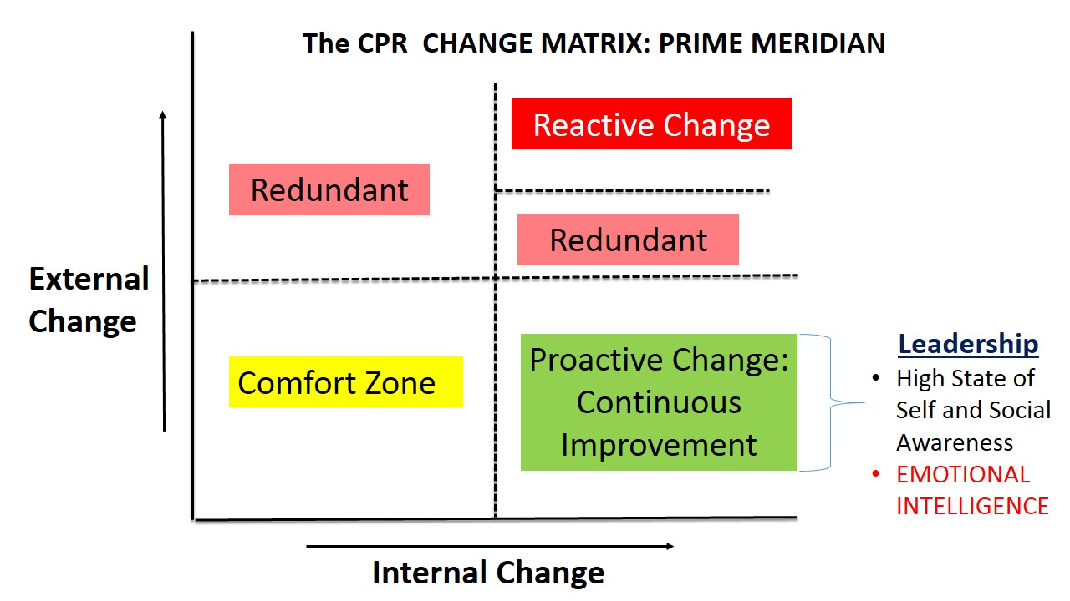

Not being able to proactively navigate this change trajectory has often cost businesses and individuals dearly. A spectacular example is the experience of XEROX Corporation finding itself left gasping for breath as the PC revolution took the world by storm. This was in spite of the fact that Xerox PARC had in its armoury innovations like the graphical user interface and the mouse. A more recent experience is the implosion of Blackberry (from a market value of nearly $80 billion in 2008 to a mere $4.3 billion), finding itself outwitted by the revolutionary strides made by competitors who were offering superior features to eager mobile consumers on iOS and Android platforms at breathtaking speeds. Even as Blackberry made desperate attempts to woo customers who were already spoilt for choice, its lack of focus on innovation proved to be an Achilles heel. A company that dominated the enterprise market was suddenly looking clueless about the arrival of the “app economy” that was driving the smartphone landscape, with smartphones emerging as full-on entertainment hubs.

While these examples relate to large corporations, a careful look will give enough lessons for individuals too. As the saying goes, success itself can sow the seeds of future failure, if we allow ourselves to be lulled into a sense of complacency in the comfort zone. In an era of feverish paced changes, that is an extremely dangerous strategy to adopt.

Strengthening leadership capabilities across the board offers the hope to regain competitive edge and to respond in a nimble fashion to rapid changes.

It is precisely for this reason that a team of highly experienced leaders, coaches and trainers joined hands and designed “Inner Power” as an enabling platform for organizations, leaders and working professionals in the quest for excellence. Through this platform, it is our endeavour to help people continuously scale greater heights of achievement, and always stay ahead of the race. We organize big workshops and learning events to enable people to unlock their true potential, lead and embrace change, and emerge real winners in their careers, businesses and beyond. The events comprise of a series of theme based workshop sessions to strengthen the core beliefs of individuals to lead and excel in all aspects of life (professional & personal).

In our pursuit of a truly transformational experience, we propose to bring renowned inspirational achievers, thought leaders, and industry stalwarts to deliver keynote addresses for the various themes lined up as part of the “Inner Power” events. Each keynote speech will set the ball rolling for the series of workshop learning activities and deliberations related to that particular theme.
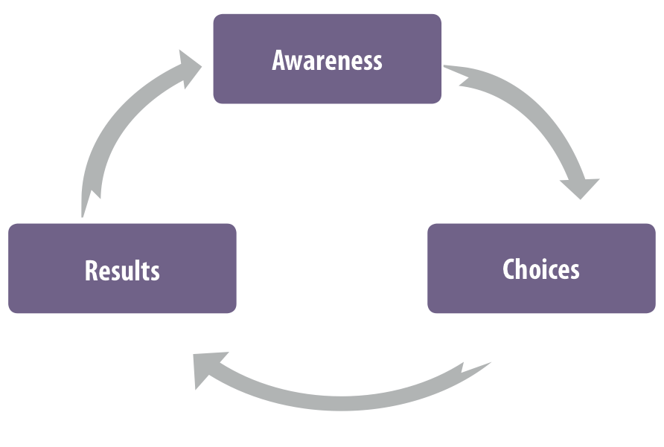

Zoom Out
Awareness precedes choice and choice precedes results. – Robin Sharma
Cycle of Change

Principal Themes

Leadership & Coaching Culture for High Performance
Leadership and coaching principles to drive high performance in yourself and your team
- Leading, managing and becoming the change that you wish to see
  - Nurturing leadership regardless of the position or space that one currently occupies
- Deploying a culture of coaching to cultivate a deep sense of ownership and empowerment
  - Solution Orientation: Developing an insight driven thinking and communication style to explore creative and meaningful possibilities

Jumpstarting Performance by harnessing Passion, Belief & Adaptability
This segment mainly focuses on defining a blueprint for achieving one’s peak potential, in career, business or in personal areas of life.
- Understand how to channel passion and belief to move towards your peak potential
- Develop habits and patterns that keep you in the zone of peak performance
  - Defining goals that ignite inspiration to zoom ahead with an evangelist zeal
  - Routines to electrify yourself with passion and zealous belief in your ability to embrace and master radical change
    - Sustaining high congruence with your values to step-up motivation
    - Navigating change with fun and happiness
  - Superior analytical capability to analyze current reality with crystal clarity and no blinkers
    - What’s working and what’s not, and to what extent am I near/away from my desired outcomes?
    - Use industry best-practice frameworks like Pareto principle, Fishbone analysis
  - Define solution maps to adapt best by developing and boosting strengths, capturing opportunities and mitigating threats
  - Galvanize yourself with breakthroughs
    - unleash yourself from limiting beliefs, un-resourceful patterns, and debilitating emotions

Secondary Themes

Emotional Intelligence for Peak Performance
- Mastering emotions to take command of the journey to peak performance
- Releasing yourself from the stranglehold of un-resourceful emotional reactive patterns
- Strengthen your relationship with yourself and others

Self Care & Personal Energy Management:
- Transforming fitness and wellness to transform businesses
  - Tapping into the power of the Mind-Body-Soul Connection for Peak performance
  - Pursuing outstanding excellence with total wellness
  - Diet and Nutrition tips to “rev it up” and “add fuel to the fire”!
- Personal Energy Management: Channelling self-inspiration for transformational change
- Channelling the personal energy and innate charisma for peak performance
- Energy management practices, routines to manage your state and pursue superior results with resourcefulness
- Navigating crests and troughs in your journey towards peak performance with a sense of equanimity
- Regain and retain a winner’s attitude and make excellence a way of life

Influential Communication
- The Life Changing Discipline Called Communication
- Learning the Fine Art of Building Long-term Relationship & Image
- Winning the Battle Each Time, Every Time And Almost All The Time
- Communication As A Tool To Proactively Handle Stress
- Acquiring the Role of Moral Leader Before Using the Power of Formal Leader

Self-Inspiration:
- Strengthening the inner beliefs, to focus on positive outcome and removing mental hurdles (intro to eft)
- Our life’s quality is directly connected to the stories we tell ourselves: understanding our internal communication to sculpt a success story
- Visualizing success journey, picking inspiration from our very own life.

Contribution/Fulfilment
- Fulfillment comes from giving
- Contribution beyond yourself. The secret of living is giving

Themes
The themes have been organized as principal and secondary themes. During the event, the principal and secondary themes will be seamlessly dovetailed together to create a powerful learning experience.

Principal Themes

- Pavan Bakshi
- Prarthana Prateek Kaul
- Suresh Sivaraman

Secondary Themes

- Raphael Joseph
- Jeanne-d'Arc Jabbour Rajagopal
- Shwetha Bhatia
- Sunil Bahirat

Who should attend?
- Do you think about increasing the scale of your achievements (take up big, bigger and audacious goals) and realize targets with passion, energy and great satisfaction?
- Are you excited to take calculated risks, go for the jugular, take on radical change and simply not settle for a life of mediocre results?
- Do you want to conquer the limiting fears of unknown uncertainties and charge ahead with renewed confidence, self-belied and optimism to manage radical change?
- Do you wish to stay on top of the game in your chosen field, and stay ahead of competition?
- Are you keen to demonstrate superior leadership capabilities to increase your success at workplace and beyond?
- Will you be excited to create bold & pragmatic plans, and move to a zone of true excellence and achievement?
- Do you wonder how amazing it would be to enjoy your successes even as you nurture fruitful relationships at workplace and in personal lives? Would you like to make that happen for real?
- Would you like to get tips on maintaining high levels of fitness/wellness/stamina to enable you master and become the change you wish to see in life?

- You could be a working professional (at any level in the corporate hierarchy), a passionate entrepreneur, or a self-driven seeker of excellence/achievement.
- Sure, you must have felt a connection to one or more (possibly more!) of the above statements.
- Then, Inner Power is indeed the place to be in September!

